Project Objective
Provide a free mechanism to aid the blind programming student to experience graphics in a more fulfilling way. In the future, we hope to generalize these ideas with the hope of improving access to graphics for more blind computer users.
Target Audience
Those with an interest and desire in using technology, particularly computer software and hardware to help the blind. These include engineers, blind students, their educators, and educators in general.
Presentation Goals
Demonstrate our tool by which a blind programmer can “see” simple graphics. Show, in a general way, the ideas behind our work. Provide a high-level view of the issues encountered and addressed.
Hopes for the Audience
Our demonstration will provide proof of concept, from which our audience will be encouraged to learn more about our work. With that, we hope to gain support for improvement and subsequently distribution and use of our tool.

Where we are, and how we got here
Our goal is to help beginning programming students, who are blind, “see” simple pictures that we often easily present to sighted students.
- Beginners, sighted or not, are often computer savvy but not programming savvy.
- Examples may be useful but are often too abstract to sustain the beginner’s attention and interest. We use pictures.
For the blind
- Our method is to transform those simple pictures into figures the blind can feel.
- We make use of a Braille printer to produce touchable figures.

A couple of examples
Starting with sighted learning
show_square_loop_colors.py - An example for the sighted
A Program to display a square with colored sides
Execute the program before a detailed explanation.
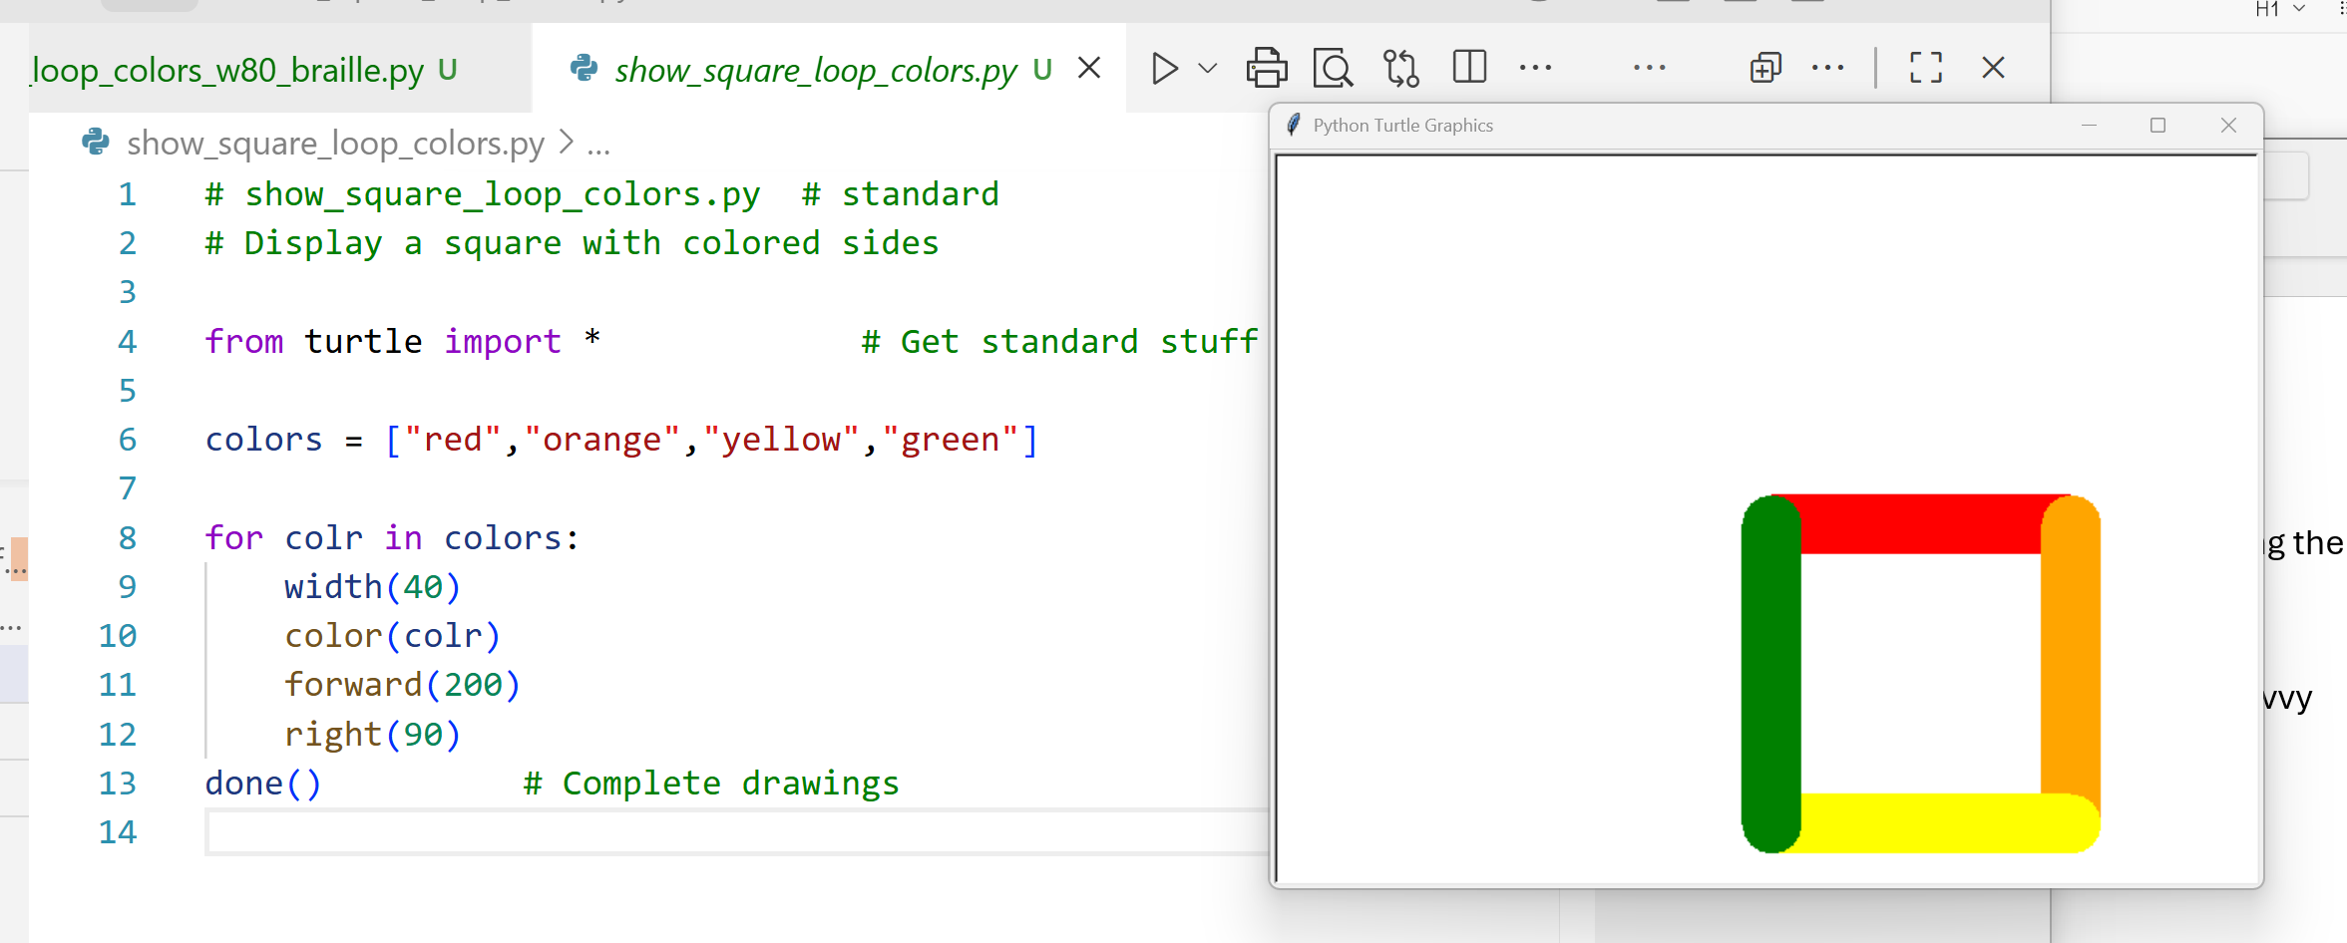
Comments
Just a description – drawing instructions – verbal “Etch-a-Sketch”
Language of our own – e.g., Best Friends for Ever - BFF, Lots of Luck – LOL
List of colors
For each color in list of colors
Line width(thickness, in pixels) – pixel, a tiny bit of screen or page
Line color
Move 200 pixels
Turn right 90 degrees
show_square_loop_colors_w80.py – same program with minor change
Just a minor change --> thicker lines
Execute program before detailed explanation.
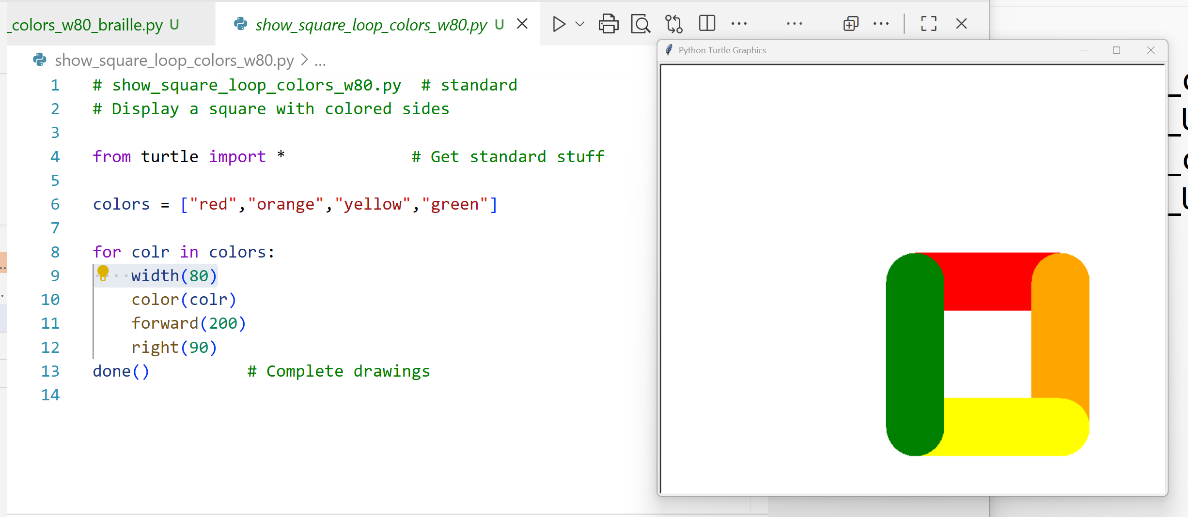

show_square_loop_colors_braille.py - our first program for the blind
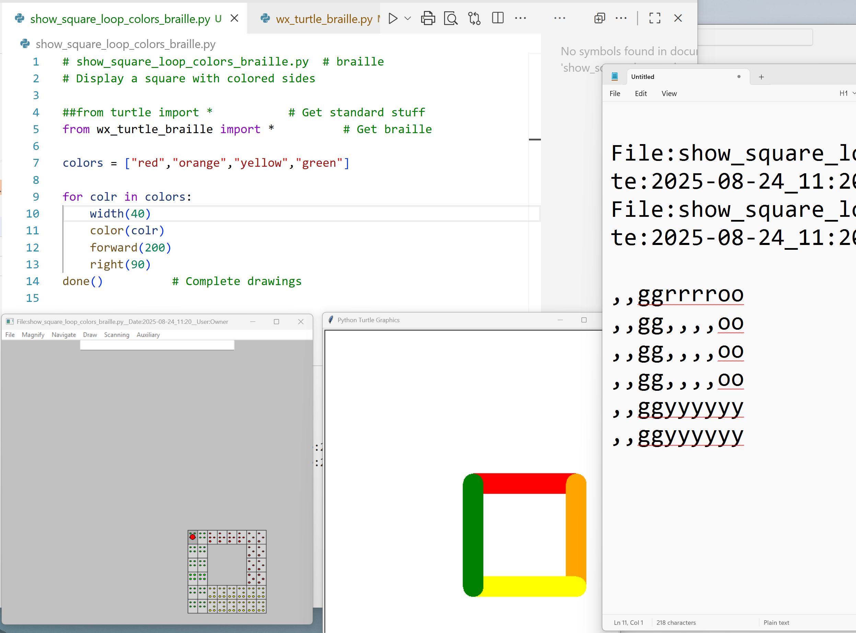

- The colored square figure that the sighted student sees.
- Window with a simulation of the Braille provided the blind user.
- A “text map” placed in the Windows clipboard. The user can “paste” this clipboard into their Braille printing application.

When printed as Braille, this text creates a touchable version of the figure.
  - Note that our students can easily paste text into an application which prints the Braille.
  - For practice and demonstration, we use the common application notepad.exe. Notepad does no Braille printing, but it shows text and demonstrates our pasting operation.
  - Start Notepad.exe to mimic application prints Braille.

Text map:
The graphics screen can be viewed as a rectangular array of 40 columns wide by 25 rows long .
One text map character stands for each one column by one row region. This character stands for this region’s color.
Each text map character is the first letter of the region’s color, “r” – red, “o”, orange,…. We use the character comma (,) to replace non-trailing blank/space areas.
Spaces as commas? Why? Hint: First time I used spaces!
Braille Window:
The Braille Window looks like the Braille printed from the text map.
The window presents each Braille character as a rectangle holding colored dots inside. These dots form the Braille six-dot code for the corresponding text map letter. For simplicity, we left the empty regions blank. To remind me, new to Braille, the dots’ color is the color of the picture’s region.
The user can navigate the Braille Window by using the keyboard. One method uses the keys positioned on the numeric keypad:
789
456
123
Move one square in one of the 8 directions: 4-left, 7-up to left, 8-up, 9- up to right,, 6-right, 3-down to right, 2-down, 1-down to left. Pressing “5” just announces the current color and location.
Navigation audio is available. Examples to follow

Creating text map from screen figure drawing:
Our software evaluates each region (one row by one column:
If the region has color, this region is represented by a “color” letter in the text map. We use the first letter of word for this color, for example, “r” for “red”.
If the region is empty, the space character is used in the text map.
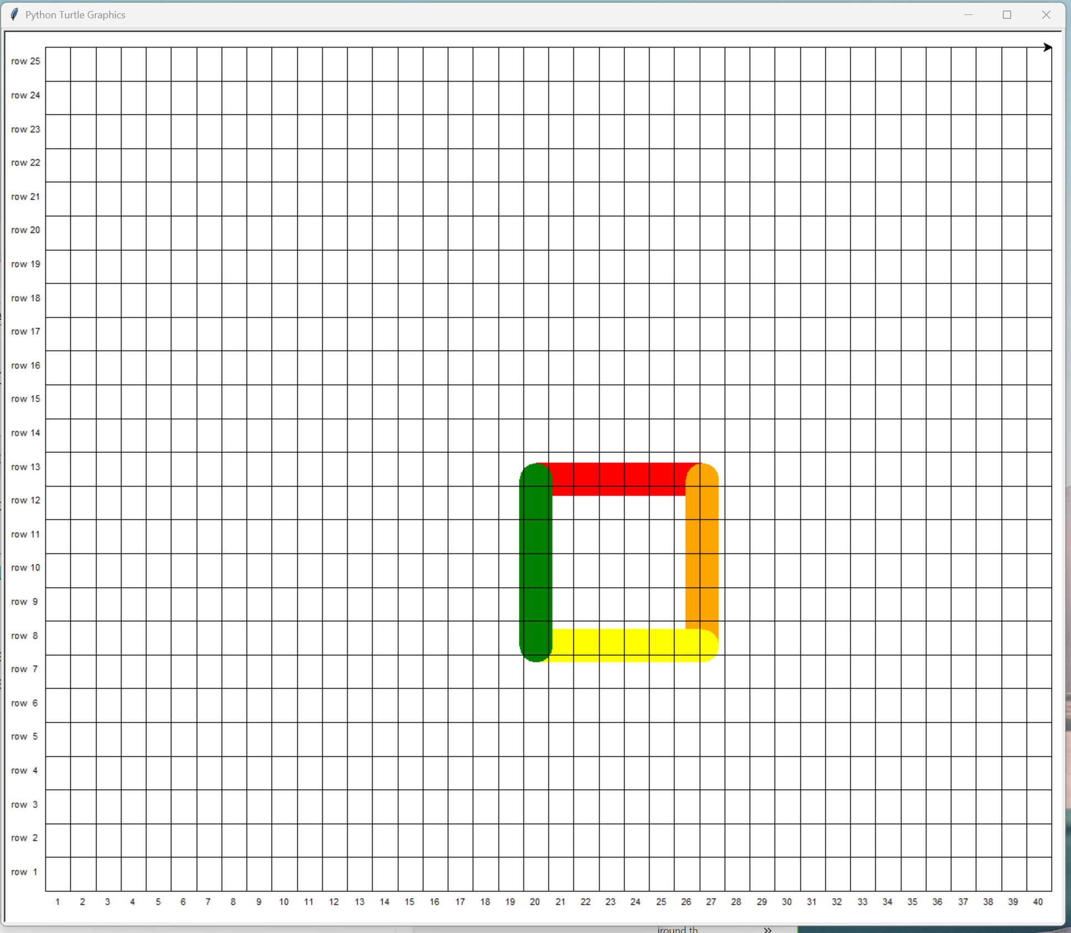
To aid Braille printing, our software performs the following actions:
- The colored figure is moved toward the upper left corner, reducing excess spaces.
- The Braille software normally compresses repeated spaces. This distorts our graphic figures. Non-trailing spaces are replaced by commas (a single dot Braille character), to avoid this distortion.
show_square_loop_colors_w80_braille.py
The smallest change – thicker line.
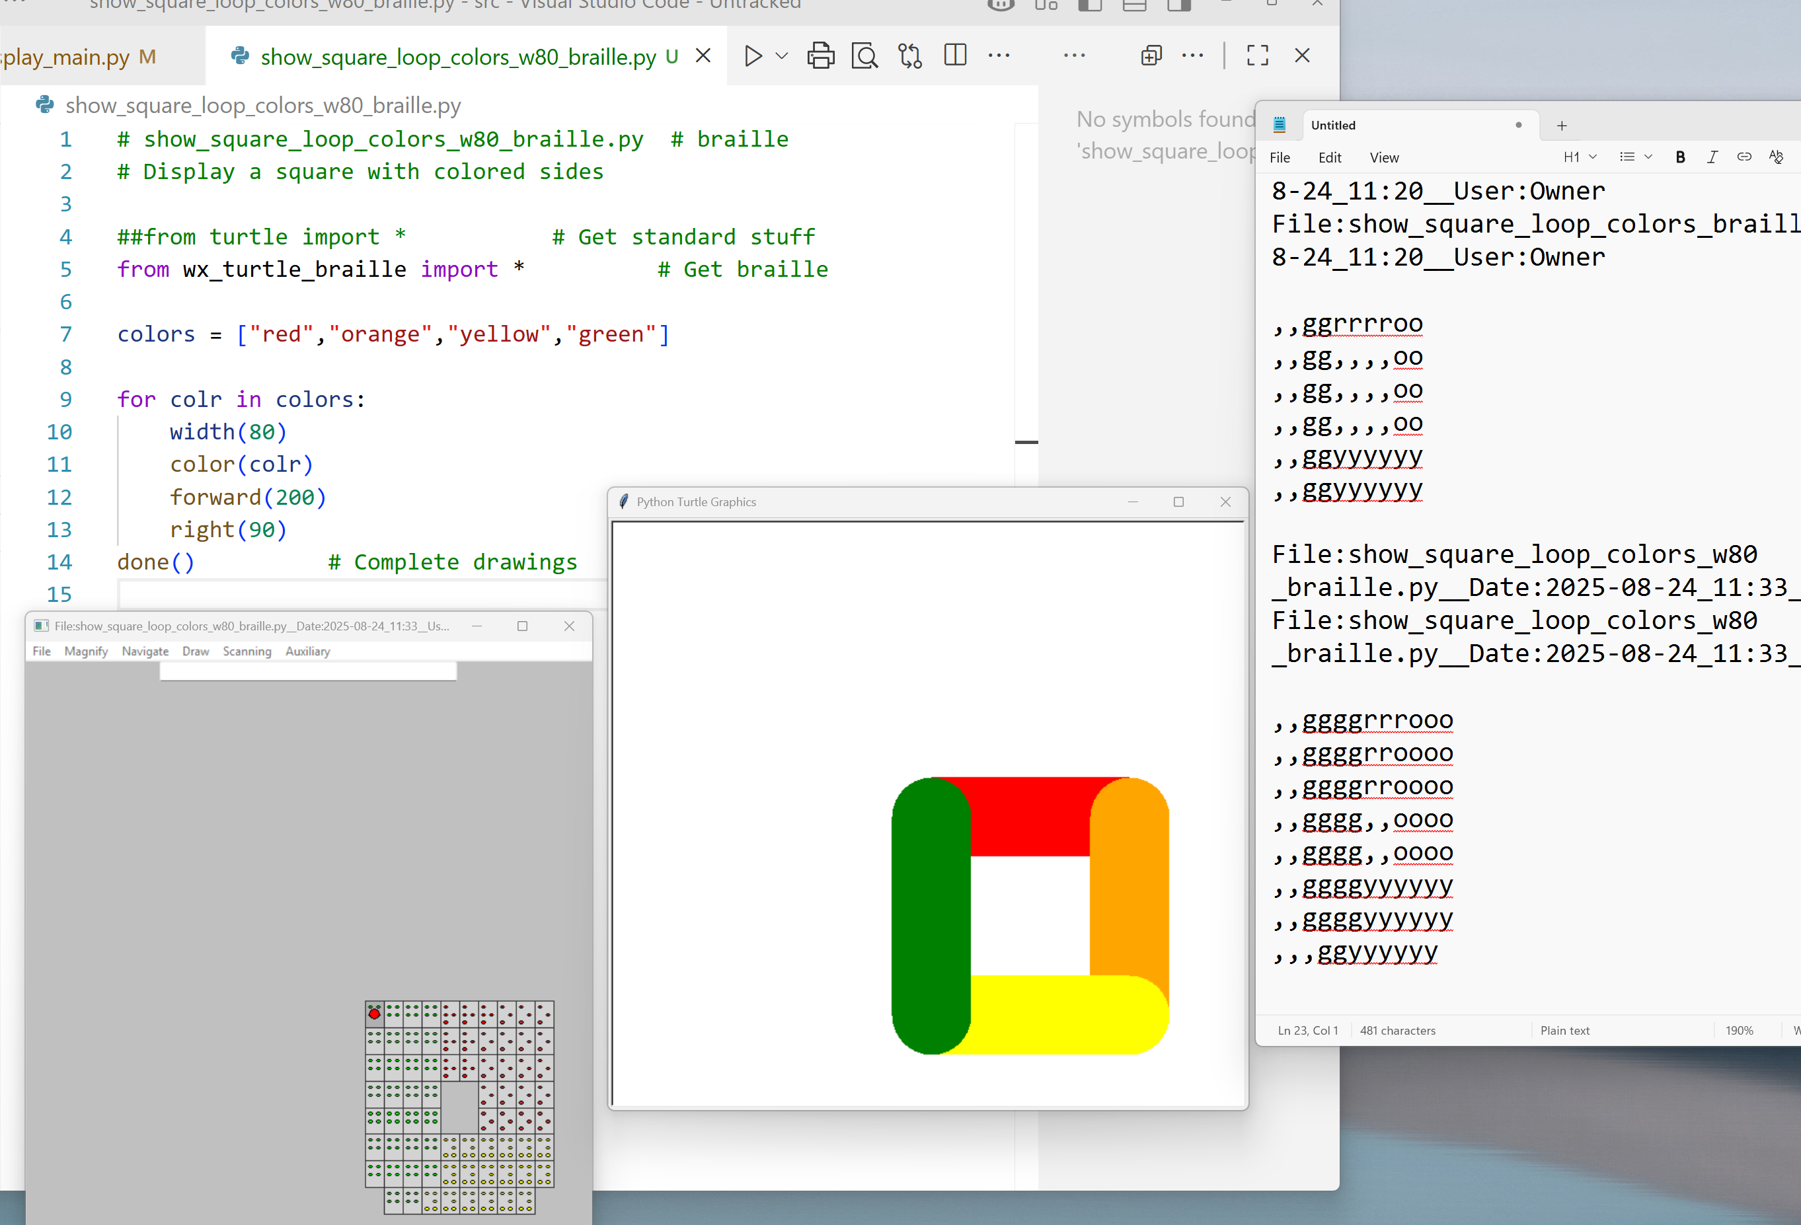
Note the thicker lines – approximate because of the coarse rendition
Paste the new map into Notepad - can send multiple pictures at once – saves walking
Navigate on Braille window, using numeric pad
4(left), 8(up), 3(down to right), 3, 3
Note that the Braille window gives audio/speech feedback.
Spoken feedback:
- The key pressed
- The region’s color
- The current location
Example:
“green at row 13 column 19” when Inside figure
or
“right 1 down 1” as instructions how to move to the figure when outside the figure.

Magnification
Select rectangle enclosing ALT+M, S
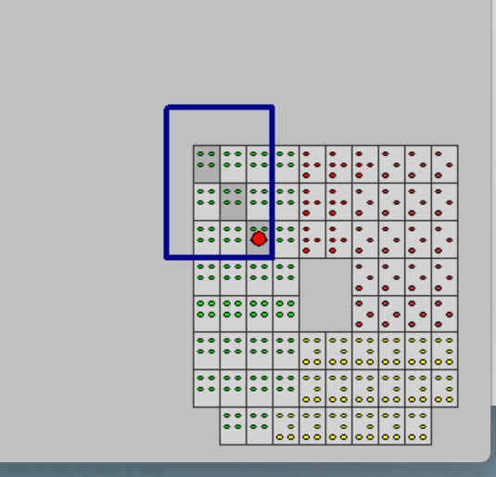
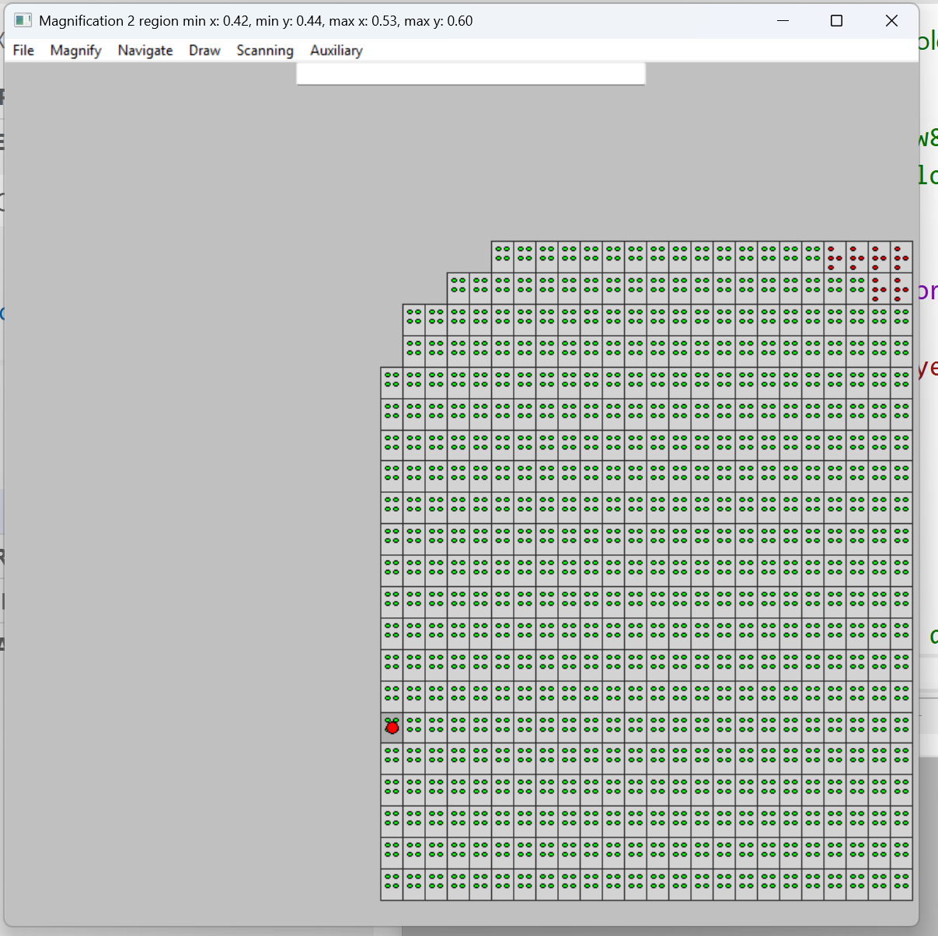

The magnification operation can be repeated.
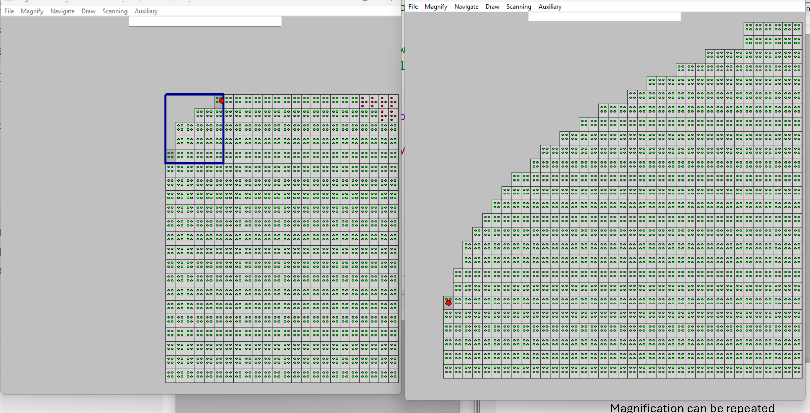

What can you do?
Our tool is a software program, written in the Python programming language. To use this tool, the user writes or is provided with a simple Turtle program to create a simple graphic such as a square. When run this program generates the standard Turtle graphics output, plus text output which when sent to a standard Braille embosser produces a “touchable” rendition of the square.
Our tool, while functional, is a prototype. We could use lots of help.
Our greatest need is a small user community which can use the tool and provide us with feedback as to its usefulness. We can use information as to the tool’s strengths and shortcomings. We would appreciate suggestions on how we can make our tool more useful. Where is it in need of improvement? What are the best points?

The program needs packaging so that we can better distribute it. The software needs testing.
NEW: The tool has been published in The Python Package Index (PyPI) as the package graphics-braille. It has mostly been tested/exercised under Microsoft Windows but has been known to have been run slightly on Macintosh OS.
From shell or cmd
Local installation:
python3 -m pip install graphics-braille
Simple Test:
gbtest

Options, such as “Expand to Top” were stubbed out, and need work. Experimental features such as perimeter scanning (the audio presentation of the perimeter of the graphics figure), need improvement.

Research, or development, of available, low cost, tools such as a reusable high speed Braille tablet would be great. Integration with high performance touch screens might be helpful.

